 | West Lothian Council  Criminal & Youth Justice Social Work Service | 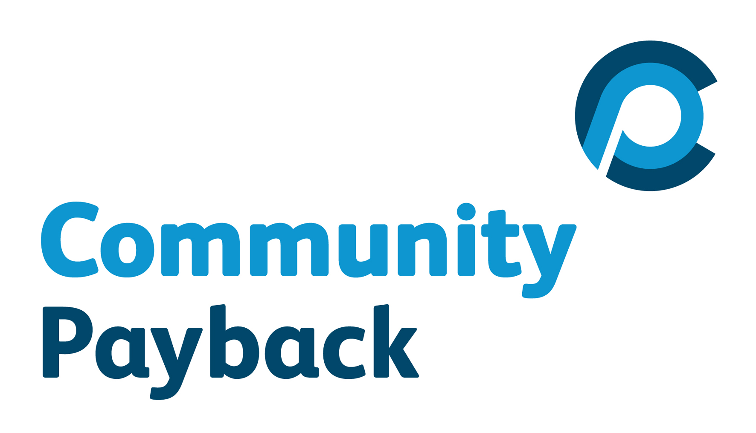
Community Payback – Work Request form
To find out more about how we work, whether your request fits our criteria, and the things we have to take into account when planning projects, please see Page 2. You need not send us that page with your request.
Details of person or organisation requiring assistance
Name of person/organisation:
Contact phone number for person/organisation:
Address of person/ organisation:
What does the organisation do?
If you are contacting us on behalf of another person or an organisation, please give details:
Your name:
Your address: |  |  |  |  |  | Postcode:
Your phone number:
Your email:
How we may be able to help you
Tell us about the work you need to have done.
How would the work that you are asking us to do help the individual recipient, your organisation or your community?
How to make your request for help – send this form to us:
Post it to: Community Payback Team, Criminal Justice Social Work Service, West Lothian Civic Centre, West Lothian Civic Centre, Howden South Road, Livingston, West Lothian EH54 6FF
Email it to: criminaljusticeteam@westlothian.gov.uk
Fax it to: 01506 281243
We will acknowledge your request within 3 working days of receipt, and we will give you an approximate timescale for getting in touch with you to discuss your project further.

About us
Offenders have been carrying out useful work across West Lothian for about 30 years. We are not allowed to take on tasks that would otherwise be carried out as part of someone’s paid work.
We can assist voluntary and not-for-profit organisations, or individuals in need. We try to make sure that all areas of West Lothian benefit from our work. While we like to take on projects where there is a wider benefit to the community, we are also happy to receive requests for small projects.
Please note that although we can provide a work-force and tools, costs for materials will be your responsibility. Our staff will discuss this in more detail with you if we are likely to be able to help you.
We need to make sure that we can carry out the work:
- To a good standard – we will tell you if we have the skills to carry out your project
- Safely – we will assess Health and Safety issues with you
- With access to necessary facilities for workers – toilets and somewhere sheltered for breaks
- At the time you need the work done.
We will acknowledge your request within 3 working days, and will give you an approximate timescale for getting in touch with you to discuss your project further. However, please note that we have a schedule of tasks and projects to carry out which may extend for several months ahead, and that we cannot guarantee being able to start work immediately. We will keep you informed about likely start dates. It is possible that factors beyond our control may delay work – an example of this would be snow falls, when all Community Payback workers are diverted onto snow clearance duties.
We will ask you, at the end of a piece of work, to give us information about how we have performed, to help us plan future projects effectively. We have by law to report annually on the work that we have carried out in the community, and we will use the information given by all recipients of work in preparing this report; we will not use information identifying any individual recipient without consent.
About Community Payback
Community Payback is a key part of the Scottish Government's new approach to community-based sentencing. It starts from the principle that community-based justice should be speedy, should be seen as relevant, and should be visible to the community.
It highlights two important points:
- That custody should only be used when it is needed, to reflect the seriousness of the offence, and for those individuals who pose risk of harm. Therefore community sentences should be the default choice for less serious offenders; and
- That sentences served in the community should involve 'payback' - that those people who have damaged their communities by their offending should make reparation to the community, and thus indirectly, to those people whom they offended against. While Payback may be through Unpaid Work or by paying compensation, the concept also includes paying back to the community by working at changing patterns of unacceptable behaviour.
While Unpaid Work is an important part of Community Payback, there are a number of other conditions that may be attached to an order, all of which are designed to reduce the risk of an individual re-offending.
Community participation is a key part of the Community Payback strategy. You or your organisation are providing useful opportunities for offenders to develop skills which may help them avoid future offending.
