









**Supporting people who care for others**

**Table of Contents**

**Foreword 3**

**Introduction 4**

**Carers Population Overview 5**

**National Context 6**

**West Lothian Context 7**

**Priority 1: Recognising, Valuing and Involving Carers 8**

**Priority 2: Health and Social Care Support 10**

**Priority 3: Social and Financial Inclusion 14**

**Priority 4: Young Carers 17**

**Conclusion 19**



# Foreword



**Alison White**

Director of West Lothian Health and Social Care Partnership

West Lothian Health and Social Care Partnership recognises the role of unpaid carers and their pivotal position as equal partners in care. Carers have a unique role in the life of the person they care for.

It is positive in this annual report to see evidence of carers, the person they care for, workers from health and social care and the voluntary sector all work together as partners in care to achieve better outcomes for all involved.

Unpaid carers are now, and will remain, fundamental to building strong families and partnerships and resilient and cohesive communities. We have a shared responsibility to support carers, to raise the profile and value of care and to work in partnership with everyone who has a responsibility to carers to ensure that carers receive the support they rightly deserve.

I want to extend my thanks, recognition and appreciation to the unpaid carers in West Lothian who continue to play such a vital role in supporting others in our communities. I look forward to our continued work together to strengthen our services and support to carers.

###### **Ann Pike**

Carer Representative, Integration Joint Board

As the Unpaid Carer Representative, I welcome the opportunity to support this 2024-2025 Annual Update to our Carers Strategy 2023–2026. This report provides an important reflection on our shared priorities and the ongoing efforts to recognise and support unpaid carers across West Lothian.

Unpaid carers continue to play an essential role in our communities, often making personal sacrifices to provide care and support to family members and friends. The Carers Strategy rightly recognises the need to value and assist carers in ways that enhance their own well-being, as well as that of the people they care for.

While there has been steady and positive activity in delivering against our strategic priorities, we must also acknowledge that progress has not always matched the urgency of the issues at hand. For too many carers, the help and support they need is still too slow in coming. Delays in action and hesitation in tackling pressing concerns have been keenly felt—particularly as the number of people requiring support continues to grow.

We have the foundations of a strong strategy, and there is evident commitment from many involved. However, moving forward, we must accelerate our pace and sharpen our focus to ensure that carers are not only recognised in sentimental words but are meaningfully supported in practice.

I extend my thanks to all those who have contributed to this work so far. Let this update serve not only as a record of our progress but as a renewed call to action—for the sake of every carer still waiting to feel heard, seen, and supported.



# Introduction

**Welcome to the West Lothian Carers Strategy Annual Report 2024–2025 reflecting on the work that has been progressed to achieve the outcomes of the Carer Strategy.**

The West Lothian Carers Strategy for 2023-2026[1] is for all people who care for others regardless of whether or not they recognise themselves as carers. All carers are recognised as Equal, Expert and Valued and the multiagency strategy implementation group continues to learn from those with lived experience to support the progress of this current strategy as well as the development of future strategies. This report provides an update on the progress made throughout the year 2024-2025 in delivering the changes and improvements that are needed to support unpaid carers to continue in their caring role alongside maintaining their own health and wellbeing.

This annual report describes how the vision for carers in West Lothian will be delivered by focusing on four key priority areas which align to the National Carers Strategy priorities. From last years Annual Report the key areas for development for this period were agreed and these have been a focus of improvement activity as follows:

**Priority 1:** **Recognising, Valuing and Involving Carers**

* Continue to develop key performance data particularly in relation to how well unpaid carers feel supported and using this information to support the delivery of key services
* Continue to raise awareness of carers rights ensuring that information is accessible

**Priority 2: Health and Social Care Support**

* To continue to promote the benefits of having an Adult Carer Support Plan
* Continue to support the workforce in relation to Self-Directed Support particularly in ensuring any unpaid carer has choice and control over the delivery of their support
* To further develop and strengthen opportunities for short breaks and breaks from caring through the revision of the Short Breaks Statement
* To launch a targeted campaign to reach older carers including promoting POA

**Priority 3: Social and Financial Inclusion**

* To launch a number of campaigns throughout the year specifically in areas where we have identified large areas of individuals who are undertaking an unpaid caring role.
* To work with local employers around Carer Positive awards and where appropriate support with the self-evaluation process

**Priority 4: Young Carers**

* Work with Education Services will develop links with the Health & Wellbeing champions in Primary schools ensuring that the role of Young Carers is understood and supported
* To continue to promote the benefits of having a Young Carer Statement

The progress of these development areas is reported within each of the priority area updates.

# 

# Carers Population Overview

Scotland’s Census 2022 reports that there were 5,294,863 people aged 3 and over living in Scotland of which 627,715 were unpaid carers caring for 1 or more people, equating to 11.9% of the total Scottish population.

In comparison there were 175,963 people aged 3 and over in West Lothian (3.3% of the Scottish population) of which **22,116 were unpaid carers**. This equates to 12.6% of the West Lothian population who provide unpaid care which is 0.7% higher than the Scottish average.

The breakdown below shows the total number of people in West Lothian in each age category in comparison to the number of carers in each age group. Whilst unsurprising individuals over the age of 35 are more like to be undertaking a caring role, carers aged between 50 to 64 is the highest percentage of people likely to have a caring role.

**West Lothian carers by age groups**

|  |  |  |  |  |  |
| --- | --- | --- | --- | --- | --- |
| Age Groups | West Lothian Population | % of population | Carers population | % of carer population | % of carers to population |
| 3 to 15 | 28,375 | 16.1% | 479 | 2.2% | 1.7% |
| 16 to 24 | 17,119 | 9.7% | 1,386 | 6.3% | 8.1% |
| 25 to 34 | 22,275 | 12.7% | 2,284 | 10.3% | 10.3% |
| 35 to 49 | 36,661 | 20.8% | 5,732 | 25.9% | 15.6% |
| 50 to 64 | 39,967 | 22.7% | 8,460 | 38.3% | 21.2% |
| 65 and over | 31,566 | 17.9% | 3,775 | 17.1% | 12.0% |
| Total | 175,963 | 100% | **22,116** | 100% | 12.6% |

**West Lothian carers by number of hours caring per week:**

Nationally 55% of individuals surveyed undertook 1 to 19 caring hours per week, with people caring for more than 50 caring hours per week equating to 25% of those surveyed. Within the local survey 50% of respondents (n=50) indicated that they undertook more than 50 caring hours which is significantly higher than the national average.

|  |  |  |  |  |  |
| --- | --- | --- | --- | --- | --- |
| 3 to 15 | 16 to 24 | 25 to 34 | 35 to 49 | 50 to 64 | 65 + |
| 31 | 150 | 578 | 1,447 | 1,682 | 1,634 |
| 1% | 3% | 10% | 26% | 30% | 30% |

Of the 5,522 people caring for 50+ hours per week the breakdown by age was:

Of the 5,522 people caring for 50+ hours per week, 60% of those are aged 50 and over (3,316 people).

Analysis will be undertaken to compare the carers census results to the numbers and ages of carers who are registered with the Health and Social Care Partnership and Carers of West Lothian to understand specifically where targeted work is required to reach people aged 50+ or caring more than 50+ hours who are not receiving information, advice and support. In addition, the analysis will help us understand the number of young carers (31) caring for 50+ hours to ensure they are receiving the support they need.

# National Context

The Scottish Government and local authorities continue recognise the invaluable contribution that unpaid carers make to wider society. Over this past year services locally continue to develop and improve services to support carers and their cared for person.

The experiences and difficulties faced by many carers are well documented and reported.

Carers Scotland published a report ‘State of Caring in Scotland 2024[2]: Health and Social Care support for unpaid carers’. This report represents the views of 1,561 unpaid carers across Scotland.

Some of the key findings include:

* Scotland’s Census 2022[3] found that there are 627,700 unpaid carers in Scotland. Carers Scotland believes that this still underestimates the true number of carers. The number is estimated[4] at approximately 800,000 unpaid carers of which at least 30,000 are young carers
* The monetary value of the contribution of unpaid carers to social care is estimated at £15.9 billion
* 80% of unpaid carers said the impact of caring on their physical and/or mental health will be one of the main challenges they face over the next year
* 63% of unpaid carers felt overwhelmed because they have not had a break from caring and 50% because of their own health needs
* Just 20% of unpaid carers have had an Adult Carer Support Plan in the last 12 months and, of those, 65% had needs identified that were not met
* Only 31% of unpaid carers had been involved in decisions about discharge from hospital with just 11% provided with sufficient support and services to protect their health and wellbeing or that of the person they care for.
* 45% of unpaid carers had sought support from social work services, but 59% of those said that support services were not there when they needed them, and 58% saying that they had experienced long wait times for assessments, reviews, care or support

In 2024, Shared Care Scotland[5], the national carer organisation undertook a comprehensive survey on unpaid carers’ experiences of short breaks and respite services in Scotland. The findings of this survey launched in their research report, ‘Exploring unpaid carers’ experiences of short breaks and respite care’[6]. A key outcome reported by carers is that they would welcome access to a break or more regular breaks from their caring role.

The timing of this research is particularly significant. It comes as the government plans to introduce a legal ‘Right to a Break’ for unpaid carers. The findings build on and reinforce many conversations already underway with carers and carer support services. They provide a robust evidence-base for urgent advocacy and reform and demonstrate that the short break needs of carers cannot be met by a legislative change alone: they need access to information, support to access breaks, and an infrastructure with the variety and capacity to meet their needs. The "Carers Right to a Break" in Scotland is part of the Care Reform (Scotland) Bill [7](formerly known as the National Care Service (Scotland) Bill. The Bill proposes to amend the Carers (Scotland) Act 2016, and the goal is to provide a more comprehensive and equitable approach to supporting carers.

The introduction of this legislation which is expected in the next Parliamentary term will be an action in the West Lothian Improvement Plan 2025-26 to ensure we are prepared for any change in law to support carers.

# West Lothian Context

In West Lothian a key focus during this period has been listening to people with lived experienced of having a caring role. Between December 2024 and February 2025, a carers survey[8] was carried out to gather carers views. A total of 103 responses were received of which 101 of the respondents had a caring role. A summary of the views gave further understanding of the unpaid caring population within West Lothian and their overall experiences of local services.

Link to summary results: [Carers Survey - Health & Social Care Partnership](https://westlothianhscp.org.uk/carers-survey)

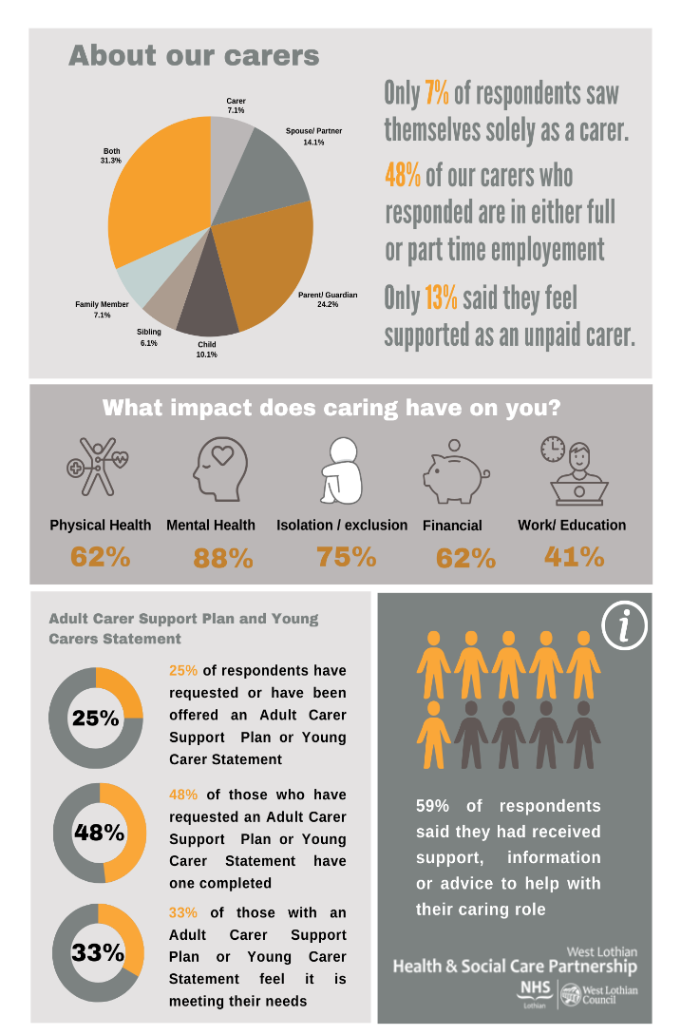

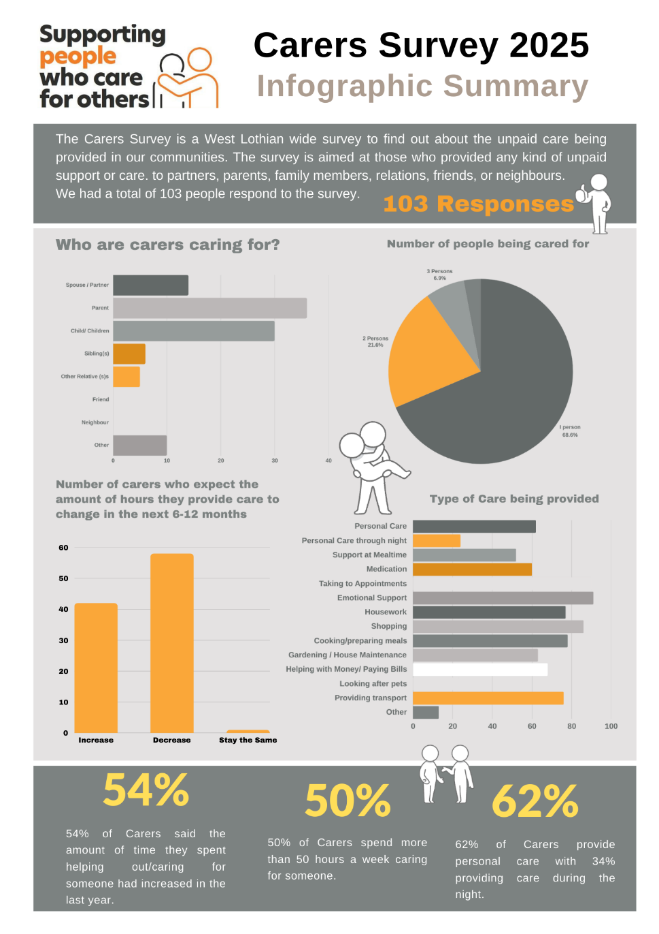

Nationally, over the last 10 years, there has been a 15% increase in the number of unpaid carers providing care of 50 hours or more each week

The majority of the respondents were white females and all respondents were aged 18 and over and therefore all the results from the survey relate to Adult Carers and nothing to Young Carers.

As a result of this a focus for 2025-26 will be targeted campaigns to reach the views of young carers, male carers and carers from BAME communities

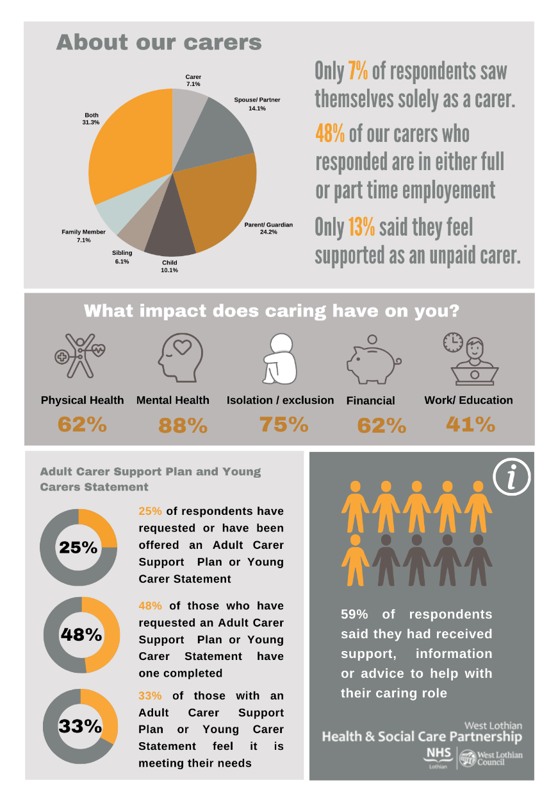**Carers were asked: Has providing support and/or care for someone impacted on you negatively in any of the following:**

From the National survey 80% of respondents reported that mental and physical health will be their main challenge in the coming year.

In the national survey over a quarter (29%) of people cared for more than one person. West Lothian is slightly higher than this at 31% of people

As the local carers centre, Carers of West Lothian (CoWL) undertook their annual survey in August 2024. They received 528 survey responses from unpaid carers, young carers and disabled people in West Lothian. Findings from this suggested difficulty in being able to access breaks from caring and the impact that this had on them.

There was a desire to have more opportunities to relax and have a break from caring, and people fed back that courses to improve general health and wellbeing would also be valued. Carers of West Lothian has been able to act on these by introducing additional courses, locality based 1-1 clinics and facilitated more breaks from caring.

The results and learning from the surveys will be included in the refreshed 2025-26 Improvement Plan focusing on all the areas of concern to carers. There will be continued efforts into supporting unpaid carers to remain happy and healthy in their caring role.

# Priority 1: Recognising, Valuing and Involving Carers

Recognising, valuing and involving carers is crucial to ensuring that the priorities of the strategic plan are embedded in service delivery and carers are receiving the information, advice and support that they need in the right format and place that is best for them. Raising awareness of carers rights has been a key focus in the period and all activities have been aimed to ensure that people who have a caring role are aware of their rights and the information, advice and support available for them.

Carers of West Lothian (COWL) is commissioned by West Lothian Council to provide an Independent Advice and Information Service to Carers and people with disabilities in West Lothian. As of March 2025, CoWL had 7,804 unpaid carers, 468 young carers and 516 disabled people registered who receive frequent information, advice and updates via various communication methods. Of those registered, a total of 2,271 unpaid carers and disabled people of which 288 were young carers were actively supported by Carers of West Lothian during the period 2024-25.

Demand for support increased in 2024-25, with 18,745 helpline telephone conversations carried out, 1,200 Facebook Messenger enquiries and 3,120 emails received. CoWL took on 3,430 instances of casework (that’s 14 cases per day). The lead source of referral is self-referral (48%), followed by NHS (24%) and social work (10%).

**Carers week 2024** starting Monday 10/06/24 and the theme was **‘Putting Carers on the Map’** highlighting the invaluable contributions of carers across the UK and ensuring their voices are heard loud and clear. Carers of West Lothian organised and co-ordinated many events to raise awareness of the support available across West Lothian and raising awareness of the needs of Carers. Staff from across the Health and Social Care Partnership attended and supported these events.

During Carers Week, West Lothian Council (WLC) employees who have a caring role were invited to a presentation by the Advice shop, detailing the support available to them. The session focused on the approach to supporting unpaid carers, outlining the various Department of Work and Pensions and Social Security Scotland benefits designed to enhance their income.

During the week training sessions were delivered by Social Policy for staff from Adult Services, Occupational Therapy & Older People services. The training highlighted the importance of good conversations, outcomes and the processes within West Lothian Health and Social Care Partnership when processing Self-Directed Support options for unpaid carers and supported people. Feedback from the sessions were extremely positive.

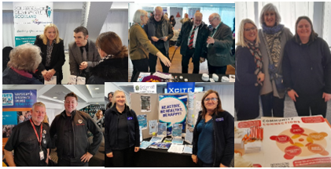**Carers Rights Day 2024** took place on 21 November 2024 and the theme was ‘recognising your rights’. To celebrate the day, the Carer Strategy Implementation Group (CSIG) organised a drop-in event for unpaid carers and their cared for person. Many internal and external partners participated to share their information and advice. Sixty people attended the event and feedback received from them, stand holders and staff supporting the event, was extremely positive. Many requests were received to hold this as an annual event which the CSIG will consider. All feedback received for improvement in services will be considered in the Improvement Plan for 2025/26.

People with lived experience of caring are represented at national and local forums by the carer representative of the IJB, the West Lothian Carer Lead and members of the Carer Strategy Implementation Group. Carers also have a voice at the Carers Voice Group organised and hosted by Carers of West Lothian as the Carers Centre for West Lothian. The opinions and needs expressed from unpaid carers is fundamental in shaping local policy and strategies including the IJB strategic Plan and the Carers Strategy.

A communications and engagement plan was agreed to ensure the involvement of staff, service user representation groups, patient and public representatives and other stakeholders are involved in the relevant events to raise awareness of carers rights and support available.

A key focus during this period has been continuing to develop key performance data particularly in relation to how well unpaid carers feel supported and using this information to support the delivery of key services. The recent West Lothian Survey results showed that only 13% of unpaid carers feel supported in their caring role. We asked them **‘what would help you feel more supported or help you to remain happy and healthy in your caring role’?** 55 people responded and themes included:

|  |  |  |  |
| --- | --- | --- | --- |
| **Respite and Time Off** | **More Information and Resources** | | **Health Services for Carers** |
| **Improved Carer Support Plans** | **Financial and Practical Support** | | **Education Support Gaps** |
| **Improved Communication** | **Legal Rights and Guidance** | | **Employment Support** |
| **Opportunities for Disabled Young Adults** | | **Access to Emotional and Practical Support** | |
| **Less Bureaucracy, More Practical Help** | | | |

Some of the Feedback included:

* *“Less focus on signposting and tea and sympathy types of services and more practical support. Investment in quality, regular respite, home sitting services, befriending, home helping services. Less leaflets and more practical support.”*
* *“I wish applications were easier especially for social work, we’re on our knees begging for help”*
* *“Spend time explaining what the prognosis is how this will impact day to day life and have a joined-up level of support. Too many different people involved, and no one wants to take responsibility or ownership so left fumbling about looking for who to speak to for questions and support.”*
* *“Far too many areas to seek support, needs to be streamlined. I hate the fact that phone lines have answering machines, and you don't get help when you need it.”*

These concerns will be addressed as part of the Carers Strategy Improvement Plan for 2025-26. Through the improvements individuals will be able to seek information and advice at a time that is convenient to them, which could increase the access to support.  This includes the development of improved referral pathways to support both adult carers and young carers to access the right level of support for them.

**The key areas of focus in 2025/26 include:**

* Review and update the Health & Social Care Partnership and Carers of West Lothian websites to ensure accessible information is available in all formats for all carers needs and there is a shared and consistent language used in all partner websites. This will include areas of support reported in the survey.
* Targeted campaigns to reach and support underrepresented carers in the survey response ie. males, young carers and carers from black and minority ethnic populations living in West Lothian.
* Agree a partnership training programme to support staff and volunteers to recognise people who have a caring role and identify what their needs are and to offer the relevant information and advice required to support that person.
* Improve the collection of data and feedback to evidence the impact the support carers receive has on their health and wellbeing.

# Priority 2: Health and Social Care Support

The Carers Strategy recognises the need to prioritise the Health and Wellbeing of carers is of critical importance to ensure carers continue in their caring role and enjoy their life alongside this role.

**Adult Carer Support Plans**

A focus for this period was raising awareness of adult carers completing an Adult Carers Support Plan (ACSP) to identify their needs and outcomes to support them in their caring role. A working group was established to focus on reviewing referral processes to ensure carers are receiving all the support they need through improved co-ordinated referral processes utilising the councils FORT (Fast Online Referral Tracking) system. This focus will continue in this coming year as it is recognised that further improvement is needed locally and nationally to raise awareness of these plans and to support carers to complete them. Results from the carers survey identified that further work is required in this area to increase the number of people feeling their needs and outcomes have been met.

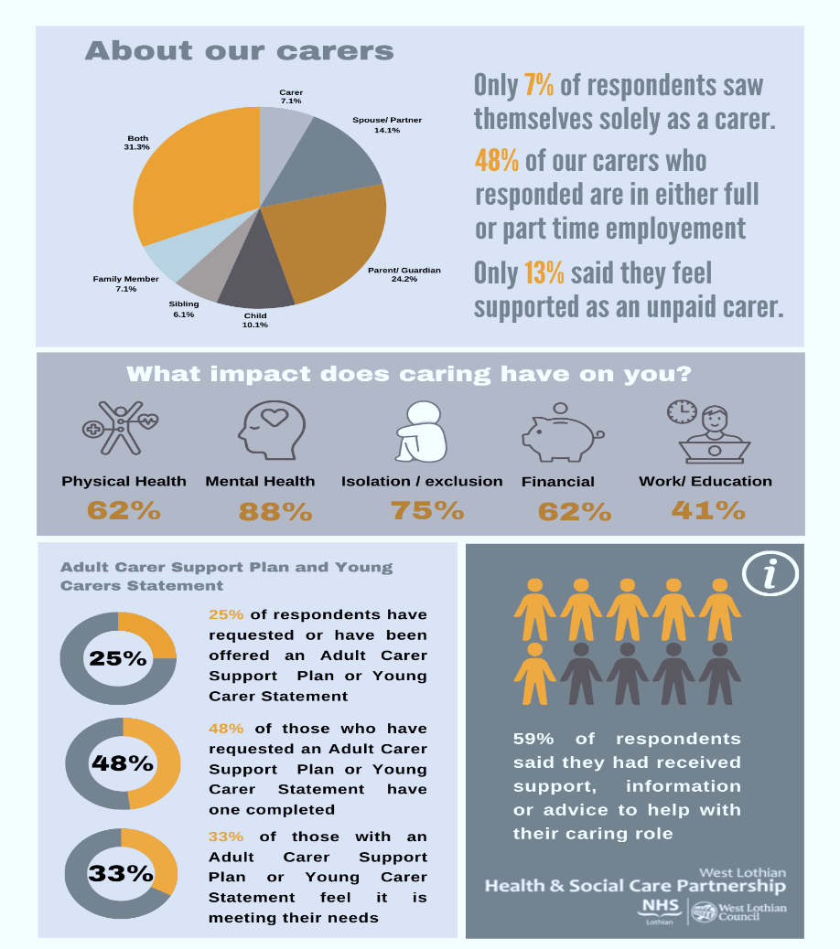

**25** carers requested or were offered an Adult Carer Support Plan

**12** of those completed an Adult Carer Support Plan

**8** of those felt it did NOT meet their needs

From the national survey just 20% of unpaid carers have had an Adult Carer Support Plan in the last 12 months and, of those, 65% had needs identified that they felt were not met

During this period 1,153 carers were offered an Adult Carer Support Plan which is consistently higher than the target of 1,000 and of those 363 (31%) chose to complete a plan which is a slight reduction on the previous year. Analysis has been undertaken to try and understand the reasons why many carers chose not to complete a plan when it is offered. Some of the feedback received was **“*I will wait until support for my cared for person is in place and I will then see how things are”* or** ***“I* *do not feel I need it at this time”***.

Changes have been made to Social Policy’s recording system MOSAIC to add a drop-down menu of reasons to collect the data of why carers decline to complete a plan. In collating this data will assist in further understanding how to support and engage with carers at the time of any assessment either for themselves or their cared for individual.

An aim of the strategy is to increase the number of carers completing an Adult Carer Support Plan. At 31/03/25 there were 50 individuals awaiting an Adult Carer Support Plan. The average number of weeks people are currently waiting is 8 weeks which is aligned to service standards. Members of the carers strategy implementation group are keen to do more around waiting times for ACSP to ensure that people are able to access support timeously to meet assessed needs and agreed outcomes.

**Self-Directed Support**

An outcome of the carers strategy is to promote and imbed the flexible use of SDS budgets to meet carers personal health and wellbeing outcomes. There has been significant work nationally and locally towards embedding the principles and values of Self-Directed Support within social care and social work. In West Lothian a training programme for staff was developed to enhance workers skills and practice when discussing SDS options with carers and their cared for person. A total of 7 sessions have been delivered to 82 members of staff and feedback was very positive including feeling more confident in supporting carers and their cared for person to have choice and control over the delivery of their support needs. Feedback received from carers has complimented the flexible and innovative use of SDS budgets.

During this period 125 carers received a financial budget to support them to meet their agreed outcomes in their Adult Carer Support Plan. Budgets have been used to purchase short breaks, practical support, sport and hobby equipment, leisure activities for themselves and in some cases with their cared for person. A few examples include:

A carer opted to purchase housecleaning support to free up his time to support and spend time with his wife he was caring for and also have some time for himself. Feedback received is: **“Having the cleaner in took some of that burden off him within his caring role.”**



A carer opted to purchase an exercise bike. This allowed the carer to have time to herself, helping her improve her health and confidence while still being close to her mother and sister.

A husband who supports his wife required support in his own right to have time to rest due to his own health issues, specifically a recent heart problem which made it difficult for him to walk his dog or keep up with housework due to fatigue. The carer opted for his wife to attend a day centre to give him a break and the support of a cleaning service and dog walker to ease practical stresses. Feedback received:

**“I just thought I would give you a quick update to let you know that my wife has settled into the day care centre and is enjoying it. On top of the personal care, the two hours of cleaning and the extra dog walking have really made a difference. I am beginning to feel the stress starting to reduce.”**

In this period, 3 year funding from ‘Support in the Right Direction’ (SiRD) was received by Carers of West Lothian and Lothian Centre for Inclusive Living (LCIL) to deliver independent Self-Directed information and advice and support.

Carers of West Lothian have utilised this funding to provide independent advice and support to unpaid carers and disabled people about Self-Directed Support. The support focuses on understanding Self-Directed Support and how to access it, preparing for social work assessment, reviews and an opportunity to talk through personal outcomes and plans for support. The support is offered via workshops, peer support groups and 1-1 support.

During this period a West Lothian Self-Directed Support (SDS) Forum was established which is a community peer support group. The group meet monthly**,** share experiences, and learn from others around the use of Self Directed Support**.**  Topics often include; choosing the right SDS option for you, managing your SDS budget, finding personal assistants or care providers, understanding your rights and responsibilities, support for unpaid carers & signposting to other sources of information and support.

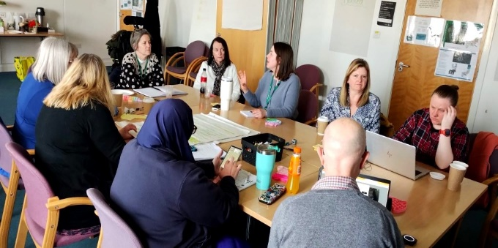West Lothian also had the opportunity to work with In Control Scotland as part of a local programme, ‘Working Together for Change’. This programme brought together professionals across the Health and Social Care Partnership as well as those with lived experience to support a local change to the delivery of SDS across West Lothian. The group commenced in September 2024 with a focus on supporting individuals early on in the social care process, through the development of short videos of community groups in West Lothian, to help support and guide people of West Lothian through the path of Social Care.

**Support Information and Advice**

Carers of West Lothian host a Counselling and wellbeing service (funded by the Scottish Government) which saw a 11.7% increase in the number of unpaid carers and disabled people accessing this service, compared to the previous year. 156 people accessed the counselling service and 37 accessed crisis support. A further 201 people benefitted from CoWL’s wellbeing support programme, which includes mindfulness sessions, stress management workshops, and other support to help manage circumstances. CORE 10, a tool to measure psychological distress, showed that the average score at the beginning of sessions was 22 vs 12 at the end.

**I think the counselling service is excellent and felt that my neurodiversity was taken into consideration greatly. This is vital and I would encourage this to continue.**

**Power of Attorney**

[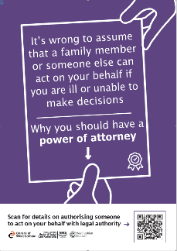](https://westlothianhscp.org.uk/article/82143/Power-of-Attorney)

To raise awareness of carers support available and the benefits of having a Power of Attorney in place for cared for people, posters were designed and distributed throughout West Lo9thian via all the organisations who participated in the carers rights day event. Additional posters were requested by Alzheimers for the dementia cafés, and the posters were also distributed to all West Lothian Partnership Centres, all Doctors Surgeries and throughout St. John’s Hospital.

[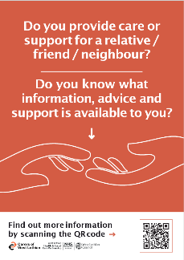](https://carers-westlothian.com/)Carers of West Lothian host Power of Attorney, Guardianship and Will clinics run bySolicitors for Older People Scotland (SOPS). The clinic was attended by 276 unpaid carers and disabled people in 2024-25, with 76 people in 2024-25 accessing further support from Solicitors for Older People Scotland (SOPS) This is a group of Scottish Law firms dedicated to providing legal services to older people in a caring and sensitive way. Approximately 60% of people qualified for legal aid.

**Click on the posters to be taken to the website for further information**

**Partnership Working**

Through funding from the National Lottery Community Fund, CoWL has strengthened healthcare links by allocating staffing time at St John’s Hospital and across the GP surgery network in West Lothian. This has resulted in a 50% increase in referrals in 2024/25 from healthcare professionals to Carers of West Lothian. This has also included attendance at multi-disciplinary meetings within the integrated discharge hub, as well as providing training to NHS staff at the hospital.

A new training programme for staff has been devised by the Advice shop, and includes comprehensive coverage of all benefits and support relating to carers, to ensure that staff are equipped to support carers and ensure that all possible avenues for support are explored.

A key aim of the strategy is to expand the use of Technology Enabled Care/Digital Solutions to support unpaid carers and their cared for person to remain living safely and independently at home. Systems such as KOMP have supported carer’s to maintain contact with their cared for person through a video link. The expansion of TEC and digital solutions will continue to form part of the work of the Carers Strategy Implementation Group.

**Breaks from Caring**

A revised short break statement for 2025-2026 has been published providing information about short breaks to carers of all ages and to the people they care for so that they:

* Know they can have a break in a variety of ways
* Are informed about the short breaks that are available
* Have choice in the support they access
* Can decide what a short break means for them and how they can be supported to meet their identified needs and achieve their outcomes

Link to the Short Breaks Services Statement: [West Lothian Short Break Services Statement 2023-2026](https://westlothianhscp.org.uk/media/46257/West-Lothian-Short-Break-Service-Statement-2023-26/pdf/West_Lothian_Short_Breaks_Services_Statement_2023-2026.pdf?m=1747046974410)

Funding made available from Scottish Government through Shared Care Scotland and administered by Carers of West Lothian provides further opportunities for unpaid carers to have a break from caring. Over this period £73,045 supporting 418 people including 155 young carers was distributed through the Time to Live fund and a further £10,645 supporting 211 people has been distributed through the provision of vouchers for those in immediate need of breaks from caring via local attractions including cinema tickets, swimming, reflexology and much more.

Feedback provided indicates a tremendous benefit to carers with:

* 97% reporting improved emotional wellbeing
* 92% indicating that there had been an improvement in the balance between their caring responsibilities and other aspect of their lives
* 97% advised that being able to access the grant made them feel valued.

In addition, Carers of West Lothian allocated hardship funds worth £12,050 to 157 unpaid carers. These were primarily used in instances of immediate need and supported unpaid carers to access food vouchers for the household at short notice. This is an allocation from the Scottish Government, administered through the Time to Live fund.

**Carer testimonial**

“I can't get to the gym as I am needed a lot at home, my husband has short term memory problems, bipolar and schizophrenia, and my son has had severe mental health problems too. It was a huge surprise to know that I was entitled to this grant and furthermore to this amazing treadmill, what a surprise! It has helps me feel valued as a person, it helps me to keep fit which then helps myself esteem and confidence, and this also helped my son who uses the treadmill too. I never dreamed I could be able to afford a treadmill, and it seemed such a waste of money to spend it on me. I would never have done this, and I never have done this in my life.”

**Carer testimonial:**

“I live with and care full time for my sister who has down syndrome, autism and a profound learning disability. I found the weekend a much-needed break from my caring responsibilities, a complete break away from my usual routine and day to day stress and strain. Doing various mindfulness practices over the weekend really improved my wellbeing and left me feeling better able to cope with my caring role.”

Carers of West Lothian also organise and host various social gatherings including gardening, meet and eat and coffee mornings to support carers Health and Wellbeing and reduce isolation sometimes caused as a result of having a caring role.

**Carers enjoying social events:**

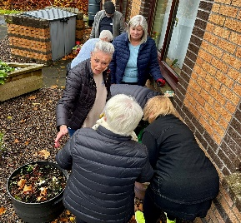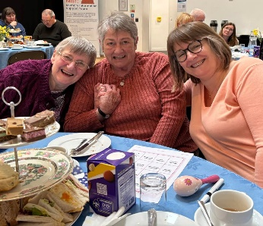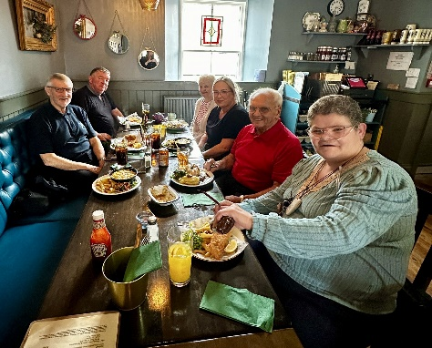

**The key areas of focus in 2025/26 include:**

* Increase the number of carers accessing an Adult Carer Support Plan to identify their needs and outcomes and help them to achieve these by utilising self-management skills, universal and community supports, short breaks through Carers of West Lothian and self-directed support.
* Prepare for the forthcoming change in legislation to allow all carers the right to a break from caring.
* Expand the choice and flexibility of short breaks available to carers

# 

# Priority 3: Social and Financial Inclusion

It is recognised that carers can often face increased financial pressures brought on by a caring role including loss of income if they have to give up work or reduce hours to support their cared for person. In addition, the household may have increased costs eg. energy as a result of the cared for persons condition.

The West Lothian Council’s Anti-Poverty Service, Advice Shop is a key partner in the Carer Strategy Implementation Group and offer support in many different areas including, welfare benefits, money and debt advice, housing and energy advice. A key focus is ensuring that carers and their cared for person(s) have their income maximised and they are receiving everything they are entitled to.

The Advice Shop offer a fortnightly drop in service at Carers of West Lothian (CoWL) office in Livingston as well as weekly drop-in sessions at the Jim Walker Partnership Centre, Bathgate, and weekly outreach

sessions in a number of locations across West Lothian. The partnership with COWL & the Anti-Poverty Service has resulted in 362 referrals to the Advice Shop, supporting 410 clients, resulting in financial gain of £1,181,473. The total annual amount of additional income generated for carers and their families through this activity was **£1,560,199** whichis a significant **87%** increase on the previous year 2023-24 of **£832,626** reflecting the increase in the number of carers and their families supported.

The graph shows the quarterly income maximised for carers and their families and reflects the awareness raising of the financial supports available for carers and their families. Along with the financial gains the Advice Shop also achieved non-financial outcomes for carers and their families which included blue badge awards, prevention of disconnection from utility companies, supply reconnection, assistance with financial debt and accessing the NHS Low Income scheme.

At August 2024, **3,321** people in West Lothian were in receipt of Carers Allowance (now known as Carer Support Payment). To be entitled to this benefit carers must be caring for someone at least 35 hours per week and the cared for person must be in receipt of a disability benefit. In addition, the carer must earn net less than £196 per week (from 7 April 2025).

Measured against other local authorities via the Local Government Benchmarking Framework, the graph demonstrates the high number of carers in West Lothian who are in receipt of Carers Allowance. This may reflect the awareness raising and support that carers in West Lothian are given to ensure they are receiving everything they are entitled to.

According to the 2022 Carers Census, **7,766** carers in West Lothian were **caring for 35+ hours per week**. Work will be undertaken to identify carers applying for carers allowance and ensure referrals are made to relevant support services and that they are offered an Adult Carer Support Plan to identify their needs and outcomes and to support them to meet these.

Meeting and engaging with all marginalised communities have also been a focus of members of the Carers Strategy Implementation group. Over this year Carers of West Lothian has embarked on proactive engagement with a number of Black and Minority Ethnic groups. This engagement has resulted in 4.8% of all cases supported were unpaid carers and disabled people from ethnic minority groups (WL population =11%). This will remain a key priority in 2025-26 to further increase support.

48% of all unpaid carers, young carers and disabled people supported by Carers of West Lothian in 2024-25 live in SiMD Quintiles 1 and 2 (areas of highest deprivation). This is significantly higher than the Scotland average of 30%. Carers are significantly more likely to live in poverty than those not undertaking an unpaid caring role and work is focused on support being equitable. One intervention aimed to achieve this is Carers of West Lothian’s locality-based interventions, accounting for 0.4 FTE staff days per week across West Lothian with specific rural areas, such as Stoneyburn, Fauldhouse & the Breich Valley.

In 2024/25, Carers of West Lothian with support from the Health and Social Care Partnership have launched carers cards. Carers Cards predominately provide an alert that indivdiuals have caring responsibilities and provide emergency contact details should anything happen to them when away from caring. CoWL have also linked in with local businesses which allows access to exclusive discounts and offers among local, regional and national businesses.

The Memory Information Support Team (MIST) project is funded by the NHS Health Improvement Fund to support families and carers of people with Dementia or experiencing memory difficulties. Carers of West Lothian launched the MIST booklet, a unique resource raising awareness of what memory difficulties may look like, and what local support are available. There is information about various forms of help available, including financial, legal & wellbeing, and all the relevant information about how and when to get support. It highlights the importance of having conversations with family when you first start seeing these changes, and including the person experiencing memory difficulties too.

During this period West Lothian Council were awarded the Carer Positive Accreditation – Engaged Status on 9 May 2024, recognising that the council provides a supporting working environment for carers and seeks to attract and retain the valuable skills that many carers bring to the workplace. This accomplishment shows the dedication to fostering a workplace culture that is supportive, inclusive, and compassionate towards carers and reflects the ongoing efforts to champion diversity, equity, and inclusivity in supporting carers in the workplace. To date 292 employees have identified as being a carer this equates to 3.6% of employees indicating caring responsibilities.

Voluntary Sector Gateway West Lothian hosted a successful Carer Positive information session with Carers Scotland and Carers of West Lothian for Third Sector and Social Enterprises in April 2024. The event was for individuals or organisations that were interested in supporting Carers in the workplace and learning more about the Carer Friendly award.  Carers Scotland provided details on the Carer Friendly Award and Carers of West Lothian (COWL) highlighted challenges faced by working carers and discussed the barriers they face themselves as employers and how they overcame these by developing their own supportive working environments.

**The key areas of focus in 2025/26 include:**

* Continue to Improve awareness of the financial and benefits advice available for carers and their cared for person
* Targeted campaigns to build awareness of the support available in areas of high deprivation for individuals who are undertaking an unpaid caring role

# Priority 4: Young Carers

Young Carers responsibilities can range from helping with household tasks and managing medication to providing emotional support. Despite their important role, young carers often face unique challenges, including impacts on their education, social life, and mental wellbeing. Often young carers do not recognise themselves as carers, limiting their access to support. In West Lothian we recognise the importance of identifying and supporting young carers and ensuring they have access to the right supports and this is therefore one of our priority areas. In this period there has been significant positive progress across all improvement plan actions and several key achievements are highlighted below.

One of the key developments is the increase in the number Young Carer Statements completed, largely driven by improved information sharing practices. A new referral pathway introduced during this period has increased referrals. However, it has also revealed process challenges and resulted in increased time required to undertake a statement and the emergence of a waiting list which is currently approximately 10 weeks. Addressing this issue and ensuring timely access to Young Carer Statements is a key priority for the coming year.

During the period 176 young carers registered with Carers of West Lothian (CoWL) and 191 young carers attended CoWL groups. In total, 288 young carers accessed CoWL support in the year. CoWL have worked to train Young Carer Champions in 100% of secondary schools in West Lothian, while 37% of Primary Schools in West Lothian have facilitated support services for their young carers.

CoWL delivered a Summer School Break programme (four weeks) with activities including day-trips, go-karting, attending Scottish, visits to local attractions and partnerships with local organisations, including Xcite, Craigsfarm, Almondvalley.

Between 7th and 9th August 2024, staff from the Child Disability Service accompanied young carers to the Scottish Young Carer Festival in Fordell Firs, Fife. This was coordinated in conjunction with Carers of West Lothian.  This event is organised by the Carers Trust Scotland and funded by Scottish Government.  Fifteen Young Carers from West Lothian visited the festival over the three days. Three Young Carers camped for the duration of the festival with a further 12 visiting for a full day of activities.  The festival enables young carers from across Scotland to gather together for a fun activity-based experience, where they can also benefit from a break from their caring role.  The Child Disability Service is keen to support this opportunity by supporting children to attend again in 2025.

The Child Disability Service in Partnership with Carers of West Lothian delivers a young carer sibling group for children known to the Child Disability service. Following the success of this group in 2024, with 14 monthly attendees it has been extended to include two monthly groups for primary-aged children, and a new group for secondary-aged young carers. Feedback from both young carers and their families has been very positive including:

***My child enjoyed meeting other children with caring duties and time to relax and be happy, to be herself. Meeting new friends. Getting transport for my child made a huge difference and it meant they could attend”.  
  
“The group helped my child feel less isolated and realised there are other young carers just like him. My child has a better understanding of why his older sibling with special needs need more care and support when indoors and outdoors”.***

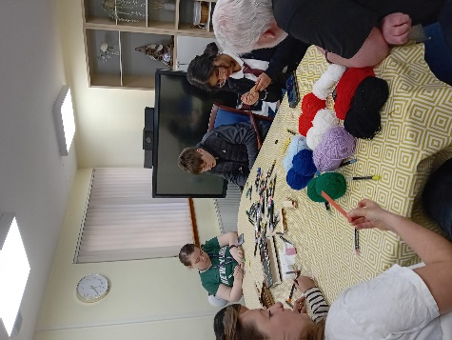

***“My child looks forward to the group and enjoys it a lot. They say it is fun, I feel happy and they say the outings and activities are exciting”***

***“I see a massive difference; my child loves the group and will happily to go each time”***

Joint information sessions delivered by the Child Disability Service and Carers of West Lothian to school staff have been well attended and positively received. Carers of West Lothian now has a dedicated Primary School Worker who is actively engaging with primary schools—building relationships with staff, delivering assemblies, meeting new young carers, and establishing new support groups for primary-aged children. Additionally, a new digital e-pack has been created, offering a class resource and lesson plan to raise awareness and support young carers in schools.

Every secondary school in West Lothian now has an identified Young Carer Champion, with young carers coming together each term. Progress also continues on the development and refresh of digital training and resources for all school staff, accessible via SharePoint and Glow. A trainee from the Educational Psychology Service is currently working with children to develop a "Pupil Voice Gathering Tool" to support meaningful discussion and feedback.

In Scotland, the Young Carer Grant [9] is a yearly payment of £390.25. It's designed to support young carers aged 16, 17, or 18 who provide care for one or more people for an average of 16 hours a week.

West Lothian is the 10th most populous local authority area in Scotland, yet it stands out for having a notably high number of young people who have both applied for and successfully received the Young Carer Grant. During the reporting period of 2023-24, a total of 165 successful Young Carer Grant applications were made by young people in West Lothian, resulting in a combined grant value of £57,864. This reflects strong local awareness, engagement, and support in helping young carers access the entitlements available to them.

**The key areas of focus for young carers in 2025/26 include:**

* Review and development of the Young Carer Statement referral pathway and supporting processes
* Ongoing engagement with primary and secondary schools, to clarify the role of school staff in identifying young carers and completing Young Carer Statements. This includes establishing consistent data collection methods to track the number of identified young carers and statements completed annually.
* Encouraging trusted adults across services including those already working closely with a child to take a more active role in completing Young Carer Statements where appropriate.
* Extend consultation methods with young carers, using feedback from young carers and the emerging Voice Gathering Tool to ensure their views continue to shape service development.

# 

# Conclusion

Carers continue to play a vital role in society and there is a long positive history in West Lothian of working in partnership with unpaid carers. As the demands of caring become greater and more challenging it is important that carers are aware of the support available to them to continue in their caring roles as well as staying in good health themselves.

This annual report looks to highlight the key achievements of the work that has been progressed in the second year of the West Lothian Carers Strategy for 2023/26 and whilst this work does not sit in isolation there continues to be a commitment to ensure that all those that are undertaking an unpaid caring role have the right support at the right time.

Members of the Carers Strategy Implementation Group acknowledge that the impact of the Carers Strategy 2023-2026 has some way to go to achieve its key aims and throughout have identified the key actions and areas of priority based on the previous and current experiences of those undertaking an unpaid caring role.



**Supporting people who care for others**



1. [West Lothian Carers Strategy 2023-2026](https://westlothianhscp.org.uk/media/58141/West-Lothian-Carers-Strategy-2023-2026/pdf/West_Lothian_Carers_Strategy_2023-2026.pdf)
2. [state-of-caring-health-and-social-care-2024.pdf](https://www.carersuk.org/media/j1bnykxm/state-of-caring-health-and-social-care-2024.pdf)
3. [Scotland’s Census 2022 - Health, disability and unpaid care | Scotland's Census](https://www.scotlandscensus.gov.uk/2022-results/scotland-s-census-2022-health-disability-and-unpaid-care/#section4)
4. [Supporting Carers in Scotland | Carers Trust Scotland](https://carers.org/our-work-in-scotland/our-work-in-scotland)
5. [Shared Care Scotland](https://www.sharedcarescotland.org.uk/)
6. [Carers Survey Research Report 2024 | Shared Care Scotland](https://www.sharedcarescotland.org.uk/policy-practice-development/carers-survey-research-report-2024/)
7. [Delivering Social Care reform - gov.scot](https://www.gov.scot/news/delivering-social-care-reform/)
8. [Carers Survey - Health & Social Care Partnership](https://westlothianhscp.org.uk/carers-survey)
9. [Young Carer Grant - mygov.scot](https://www.mygov.scot/young-carer-grant)